# ASSOCIATION OF CIVIL ENGINEERING SOCIETY

**Free-cad “A Designing Contest”**

**Event – report**

ACES organized a 3D designing competition from 11th October to 14th October on **guru.gndec.ac.in** portal. In this contest the participants has had to make a **3D** design of a **2BHK** house of dimensions **12m x 15m** in **FREECAD** of their desire.

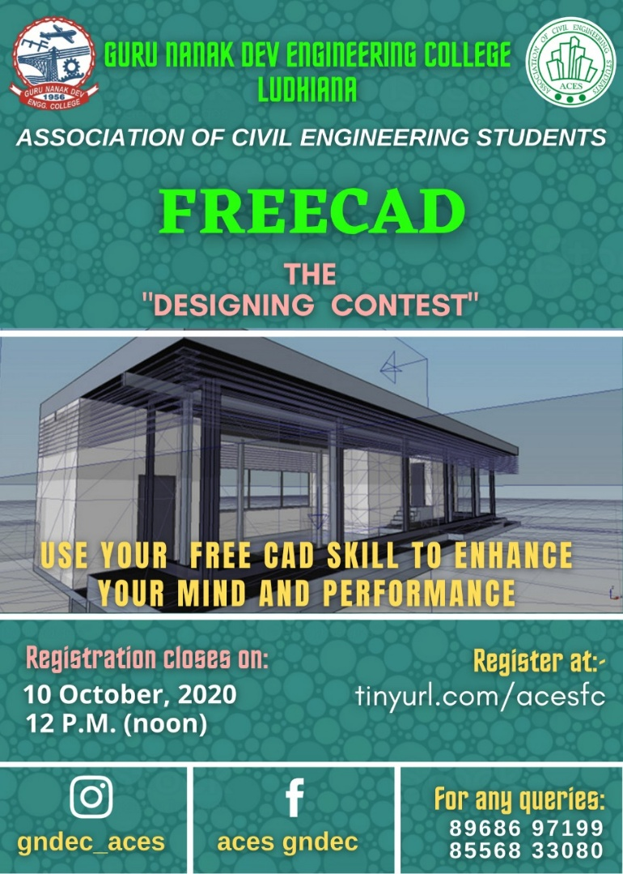

We got really amazing response, participants showed their **creativity** by creating a House with all the comfort.

**Winner**

* **Name: -** Ujjwaldeep Singh
* **Year: -** D3
* **Branch: -** Civil
* **U.R.N: -** 1805117

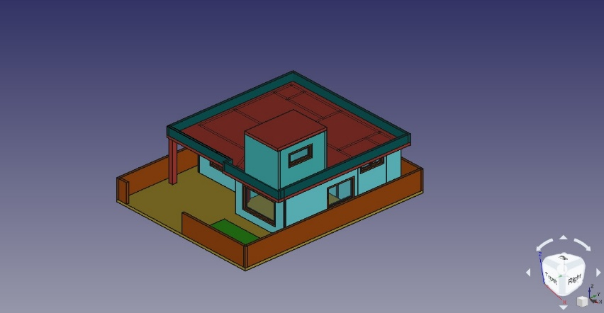 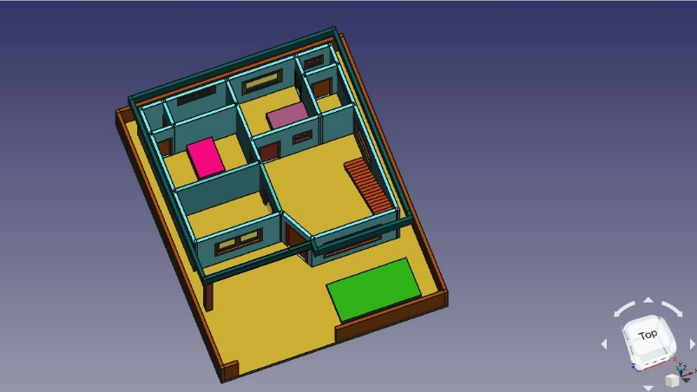

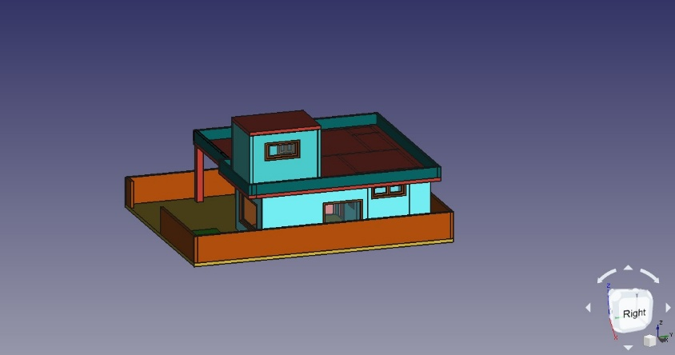 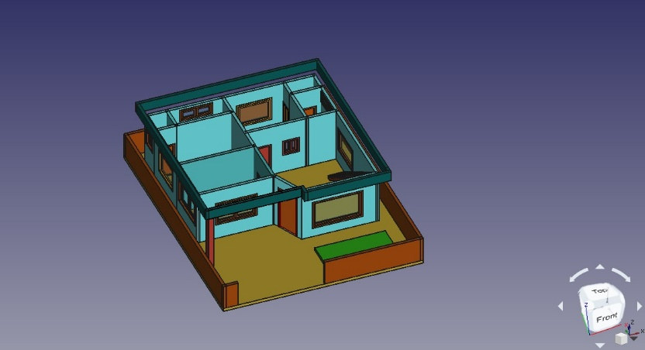

**Organizers of the event**

|  |  |  |
| --- | --- | --- |
| **Name** | **Year** | **URN** |
| Sharanjit Singh | D2 | 1904922 |
| Ananya | D2 | 1904816 |
| Nikhil | D2 | 1904890 |
| Shiv partap dubey | D2 | 1904925 |
| Ritik Sagar | D2 |  |
| Manpreet Singh | D4 | 1805076 |
| Charanpreet Singh | D3 | 1805029 |